**Thank you for taking your time to learn more about kidney disease and possible kidney donation.**

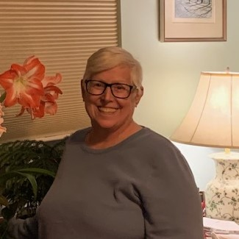

**Nancy Counihan needs a kidney to live.**

**Why Donate a Kidney?**

Patients with end-stage kidney disease have three options for treatment: 1. Dialysis, 2. Kidney transplant from a deceased donor, or 3. Kidney transplant from a living donor.

With dialysis, a machine is used to clean the blood, doing the work of a healthy kidney. It’s time-consuming and exhausting. A patient undergoing hemodialysis must go as frequently as three times a week for up to four hours each session. With peritoneal dialysis, a machine is used to filter waste in the peritoneal cavity. This process may be done at home while the patient sleeps. However, it should be done every day (or night) for up to 10 hours. The preparations are very time-consuming. It requires a sterile environment and a large area to store the medical equipment and supplies needed.

While a patient can remain on dialysis for many years, it’s not a cure for kidney disease. In fact, ten percent of patients on dialysis die each year while waiting for a kidney transplant. A kidney transplant is the preferred treatment option for patients with end-stage kidney disease. But the demand for kidneys from deceased donors is greater than the number available – which means patients can wait years for a kidney transplant, often growing weaker while waiting.

**The best and fastest option for a kidney patient is to receive a kidney from A LIVING DONOR. If you are considering being a donor, please tell the Ohio State University transplant center that YOU ARE DONATING YOUR KIDNEY ON BEHALF OF NANCY COUNIHAN Date of Birth June 17, 1956**

**(614) 450-2933**

**What can you do to help?**

* Take care of **your** kidneys by implementing **A HEALTHY DIET.**
* Look into becoming a **LIVING DONOR.**
* **DONATION AFTER LIFE.** Become an organ donor. This is as simple as checking the box on your driver’s license. You can also share your wishes to be an organ donor with your family and friends.
* **PRAY** for those waiting for a transplant.
* **SPREAD THE WORD: Let people know that Nancy Counihan needs a kidney.**
* **Visit our website:** [**www.akidneyfornancy.com**](http://www.akidneyfornancy.com)



**What are the advantages for the recipient of a living donor transplant?**

* Wait times for recipients are reduced from years to months, potentially avoiding dialysis.
* Recipients have better outcomes with kidneys from living donors.
* Kidneys from living donors may last nearly twice as long as kidneys from deceased donors.
* The risk of rejection is low.

About a third of the transplants performed at Ohio State are performed with kidneys from living donors. Donors are family members, friends, co-workers and other extraordinary people ~ altruistic donors.

**Who can safely donate a kidney?**

The decision to become a living donor is a voluntary one, and the donor may change their mind at any time during the process. The donor’s decision and reasons are kept confidential.

* Between the ages of 18 and 75.
* In good overall physical and mental health, free from uncontrolled high blood pressure, diabetes, cancer, HIV/AIDS, and organ disease.
* Gender and race are not factors.
* **YOU DO NOT NEED TO MATCH NANCY. Ohio State Transplant Team will coordinate with other donors to find a matching kidney.** It is possible to donate with mismatched blood/tissue through Kidney Paired Donation (KPD).

**Kidney Paired Donation**

Sometimes, a person may agree to donate a kidney to a recipient, but his or her blood or tissue type does not match their recipient. Ohio State’s Comprehensive Transplant Center can help match such a donor/recipient pair with another donor/recipient pair through a process called Kidney Paired Donation (KPD). For example, if the recipient from one pair is a match with the donor from another pair and vice versa, Ohio State Transplant Center can arrange the exchange through two simultaneous transplants. This allows the two recipients to receive organs from two people who were willing to donate, even though the original pairings were incompatible or mismatched.

**What are the risks of donating a kidney?**

* Living kidney donation surgery is a relatively low risk procedure, but there is still a potential for complications.
* Life expectancy after donation is the same as that for people with two kidneys.
* Donors are tested and re-tested prior to surgery to ensure the best outcome. Only healthy people are accepted as donors.
* It is recommended that female donors wait at least 6 months after surgery to become pregnant.

**Who pays for the kidney donation surgery?**

The recipient’s medical insurance generally pays the cost of the living donor’s evaluation, testing and surgery, and therefore, the donor should not incur any medical expenses. However, time off work and travel expenses need to be considered. The usual recovery time for a donor is four to six weeks.

Some donors may be eligible to receive financial assistance for donation expenses like transportation, parking and hotels. There is no financial assistance available for lost wages. A new Ohio law gives state employees paid time off work for donating.

**What is recovery like after donating a kidney?**

* Surgery is usually performed laparoscopically, meaning smaller incisions requiring a shorter hospital stay for faster recovery.
* Most donors can go home the day after surgery.
* About a week after surgery, donors generally report feeling tired but ready to go about normal activities.
* Driving may resume one to two weeks after surgery, and depending on the occupation, can usually return to work in two to four weeks.
* For the first six weeks, donors are restricted from lifting anything over five to ten pounds.
* After that six-week period, all normal life activities can be resumed.

**How to start the process to be a living donor**

Start the assessment process to be a living kidney donor by completing the online health history questionnaire. Once completed, your information will be reviewed by the Ohio State University Transplant Team. If you're a potential candidate, one of the Ohio State University Living Donor Team members will contact you directly. If you have questions at any time, please email an Ohio State living donor team member at [**livingdonor@osumc.edu**](mailto:livingdonor@osumc.edu?subject=LKD%20Question) or call **614-293-6724, option 3**.

**To start the living donor processes please go to**  [**https://wexnermedical.osu.edu/transplant/living-kidney-donation**](https://wexnermedical.osu.edu/transplant/living-kidney-donation)

**Again, thank you for taking your time to learn more about kidney disease and donation.** *If you are considering being a donor, please tell the transplant center that* **YOU ARE DONATING YOUR KIDNEY ON BEHALF OF:**

**NANCY COUNIHAN**

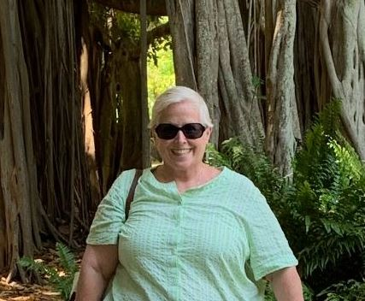

**Date of Birth: June 17, 1956**